**Name: Sunil Kunwar Roll No.: 114 IIB Date: 2080-05-25**

**M. Sc. 2nd Semester General Lab – 01**

**STUDY THE ABSORPTION OF β-PARTICLE BY USING ALUMNIUM AND COPPER ABSORBER AND ESTIMATE THE END-POINT ENERGY OF THE GIVEN β-SOURCE.**

**APPARATUS REQUIRED:**

1. GM tube and counter
2. Beta source
3. Aluminum plates of different thickness
4. Copper plates of different thickness

**THEORY**

Strontium-90 is a widely used beta-emitting isotope, commonly employed in industrial applications and as a thermal power source in radioisotope thermoelectric generators (RTGs). These generators convert heat from the radioactive decay of Strontium-90 into electricity using thermocouples. Although Strontium-90 produces less power, has a shorter half-life, and requires more shielding than Plutonium-238, it is significantly cheaper due to its abundance in nuclear waste and ease of chemical extraction. Strontium-90-based RTGs have been utilized to power remote lighthouses.

Strontium-89, another beta emitter with a shorter half-life, is used in palliative care for treating bone tumors in terminal cancer patients. Both isotopes are byproducts of nuclear fission.

In beta decay, the emitted beta particles can have energies ranging from zero up to a maximum value, known as the endpoint energy. This endpoint energy corresponds to the mass difference between the parent and daughter isotopes. On average, beta particles carry less than half the endpoint energy, with the remaining energy carried away by an anti-neutrino (in beta-minus decay) or a neutrino (in beta-plus decay).

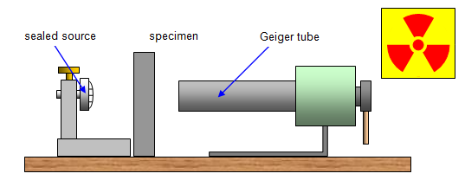

β-Source

Al/Cu

GM Tube

*Figure 1:* *The experimental setup for absorption of* β-*particle.*

The β-decay is a random process. Though it can be studied using laws of radioactivity, which is based on the laws of probability. The intensity of β-particle after passing the thickness ‘x’ of any absorber material having β-absorption coefficient µ is given by,

|  |  |
| --- | --- |
|  |  |

Here, is the intensity of β-particle at x = 0. The value of is proportional to the number of β-particles in the beam which in turn proportional to the number of counts of β-particle per second given by GM counter. If and are the number of counts corresponding to and , then,

|  |  |
| --- | --- |
|  |  |

Taking log, we get

|  |  |
| --- | --- |
|  |  |

If we make a plot between versus distance (x), the negative slope of the line gives the absorption coefficient. The maximum range R of the β-particle is determined by extrapolation of absorption curve for zero counting (or up to the level of background). The maximum range is related to the maximum particle energy E by this empirical formula,

|  |  |
| --- | --- |
|  |  |

Where R is measured in gm/cm2 (thickness density) and E is in MeV

**BEST FIT CALCULATION:**

Let and is the thickness of metal plate, then

|  |  |
| --- | --- |
|  |  |

Represents the best fitted line, where m is the slope and c the intercept.

Taking sum, then above equation takes the form:

|  |  |
| --- | --- |
|  |  |

Multiplying (5) by we get,

|  |  |
| --- | --- |
|  |  |

Multiplying (6) by and (6) by and solving these expressions for the slope (), we get,

|  |  |
| --- | --- |
|  |  |

And intercept is given by,

|  |  |
| --- | --- |
|  |  |

**OBSERVATIONS**

**Table 1:** Background Count

|  |  |  |
| --- | --- | --- |
| **SN** | **Counts per 60 sec** | **Average** |
|  | 107 | 90.80 |
|  | 50 |
|  | 110 |
|  | 98 |
|  | 89 |

So, average count per sec =

1. **Absorption by Aluminum**

**Table 2:** Counts of beta particle after placing beta source and different Al plates.

|  |  |  |  |  |  |  |  |  |  |
| --- | --- | --- | --- | --- | --- | --- | --- | --- | --- |
| **SN** | **Thickness (x mm)** | **Counts per 60 seconds** | | | | | **Average count** | **Average count per second** | **Background subtracted (N)** |
|  | 1.05 | 411 | 352 | 450 | 460 | 398 | 414.20 | 6.90 | 5.39 |
|  | 1.12 | 364 | 413 | 395 | 350 | 325 | 369.40 | 6.16 | 4.64 |
|  | 2.17 | 152 | 171 | 165 | 238 | 173 | 179.80 | 3.00 | 1.48 |
|  | 3.82 | 170 | 156 | 115 | 149 | 120 | 142.00 | 2.37 | 0.85 |
|  | 6.74 | 103 | 187 | 173 | 105 | 100 | 133.60 | 2.23 | 0.71 |
|  | 8.7 | 150 | 131 | 153 | 91 | 130 | 131.00 | 2.18 | 0.67 |

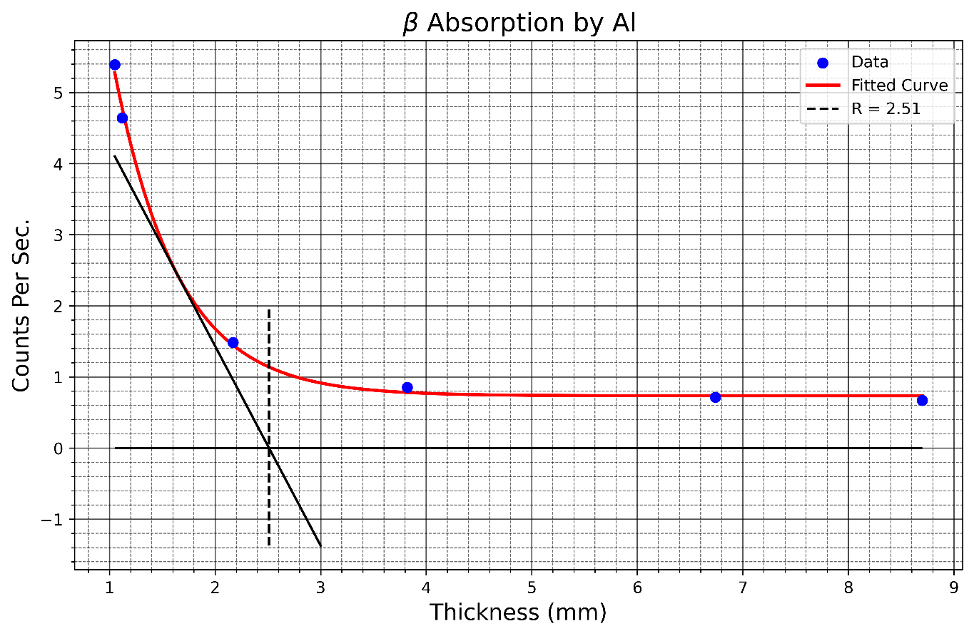

*Figure 2:* *The count rate per sec vs thickness curve for Aluminum.*

**Table 3:** Best fit calculation

|  |  |  |  |  |  |
| --- | --- | --- | --- | --- | --- |
| **SN** | **Thickness**  **()** | **Background subtracted Count (N** |  |  |  |
|  | 1.05 | 5.39 | 1.68 | 1.10 | 1.77 |
|  | 1.12 | 4.64 | 1.53 | 1.25 | 1.72 |
|  | 2.17 | 1.48 | 0.39 | 4.71 | 0.85 |
|  | 3.82 | 0.85 | -0.16 | 14.59 | -0.62 |
|  | 6.74 | 0.71 | -0.34 | 45.43 | -2.31 |
|  | 8.70 | 0.67 | -0.40 | 75.69 | -3.48 |
|  | **23.60** |  | **2.71** | **142.78** | **-2.07** |

Calculations of and using equation (8) and (9)

We have,

Comparing equation (3) and (5),

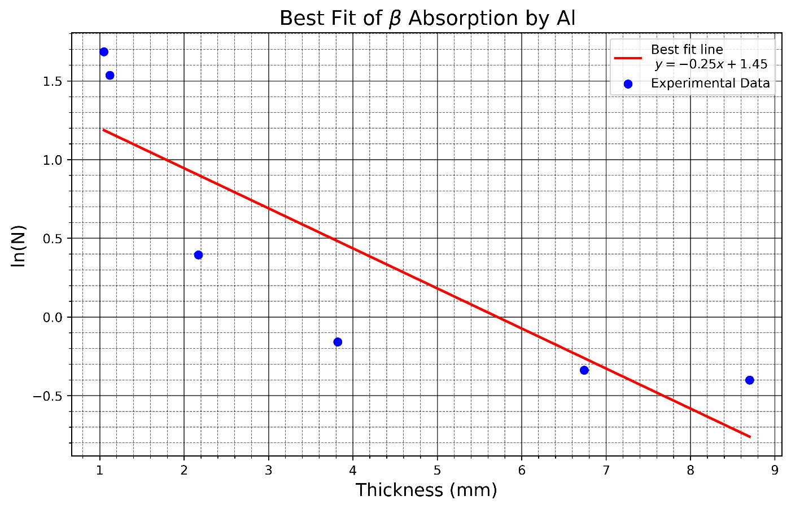

*Figure 3:* *Best fit of* ln *of count vs thickness for Aluminum.*

Absorption coefficient (

And, End point energy

**Error Analysis:**

**Table 4:** Table for error analysis.

|  |  |  |  |  |  |
| --- | --- | --- | --- | --- | --- |
| **SN** |  |  |  |  |  |
|  | 1.05 | 1.68 | 1.19 | 8.3136 | 0.2471 |
|  | 1.12 | 1.53 | 1.17 | 7.9148 | 0.1330 |
|  | 2.17 | 0.39 | 0.91 | 3.1093 | 0.2657 |
|  | 3.82 | -0.16 | 0.50 | 0.0128 | 0.4323 |
|  | 6.74 | -0.34 | -0.24 | 7.8774 | 0.0116 |
|  | 8.70 | -0.40 | -0.73 | 22.7211 | 0.1053 |
|  |  |  |  | **D=∑=49.9491** | **∑** |

Mean3.93

The error in slope is,

Hence the error in mass absorption coefficient for β-particle is =

So, the mass absorption coefficient of Aluminum for β-particle is =

1. **Absorption by Copper**

**Table 5:** Counts of beta particle after placing beta source and different Cu plates.

|  |  |  |  |  |  |  |  |  |  |
| --- | --- | --- | --- | --- | --- | --- | --- | --- | --- |
| **SN** | **Thickness (x mm)** | **Counts per 60 seconds** | | | | | **Average count** | **Average count per second** | **Background subtracted (N)** |
|  | 0.14 | 470 | 412 | 450 | 393 | 447 | 434.40 | 343.60 | 5.73 |
|  | 0.4 | 370 | 390 | 360 | 367 | 361 | 369.60 | 278.80 | 4.65 |
|  | 0.5 | 280 | 310 | 278 | 250 | 260 | 275.60 | 184.80 | 3.08 |
|  | 1.01 | 170 | 156 | 150 | 149 | 120 | 149.00 | 58.20 | 0.97 |
|  | 1.15 | 120 | 187 | 150 | 105 | 130 | 138.40 | 47.60 | 0.79 |
|  | 2.5 | 149 | 105 | 120 | 98 | 110 | 116.40 | 25.60 | 0.43 |

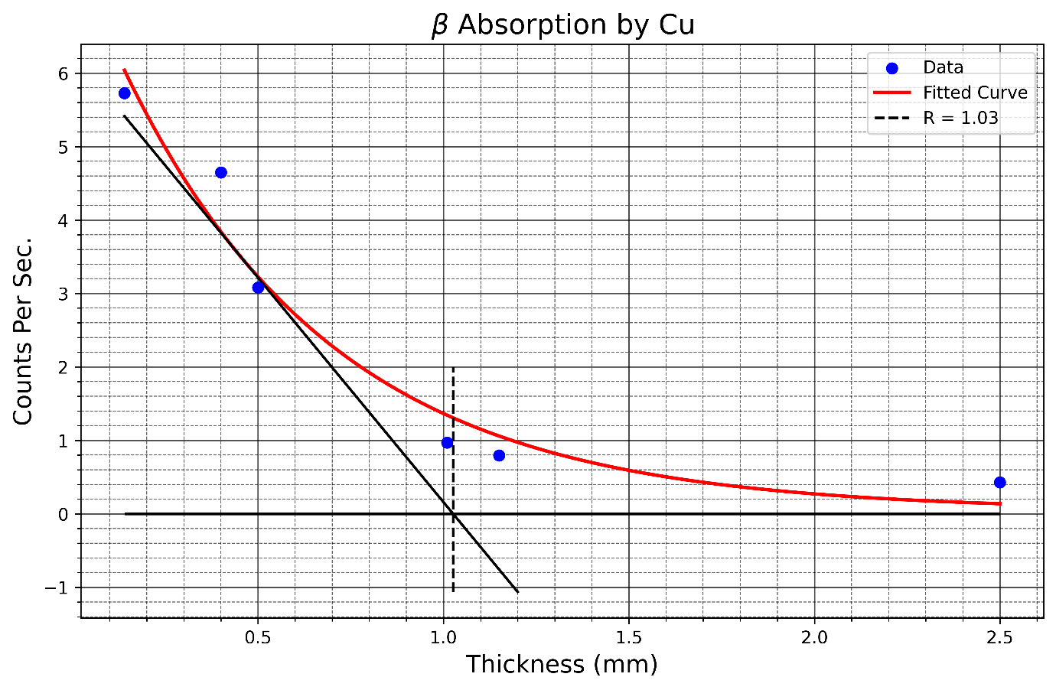

*Figure 4:* *The count rate per sec vs thickness curve for Copper.*

**Table 6:** Best fit calculation

|  |  |  |  |  |  |
| --- | --- | --- | --- | --- | --- |
| **SN** | **Thickness**  **()** | **Background subtracted Count (N** |  |  |  |
|  | 0.14 | 5.73 | 1.75 | 0.02 | 0.24 |
|  | 0.40 | 4.65 | 1.54 | 0.16 | 0.61 |
|  | 0.50 | 3.08 | 1.12 | 0.25 | 0.56 |
|  | 1.01 | 0.97 | -0.03 | 1.02 | -0.03 |
|  | 1.15 | 0.79 | -0.23 | 1.32 | -0.27 |
|  | 2.50 | 0.43 | -0.85 | 6.25 | -2.13 |
|  |  |  | **3.29** | **9.02** | **-1.01** |

Calculations of and using equation (8) and (9)

We have,

Comparing equation (3) and (5),

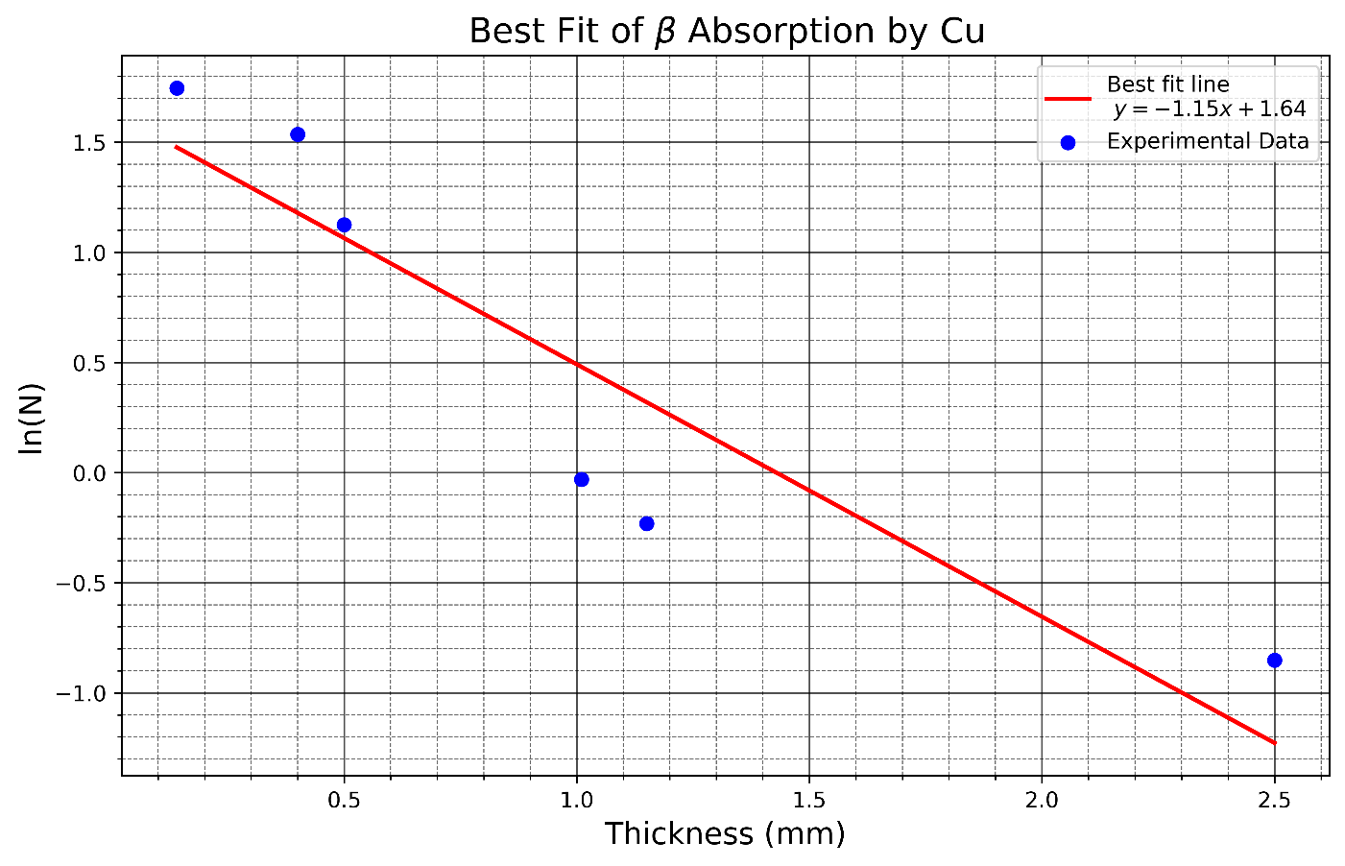

*Figure 5:* *Best fit of* ln *of count vs thickness for Copper.*

Absorption coefficient (

And, End point energy

**Error Analysis:**

**Table 7:** Table for error analysis.

|  |  |  |  |  |  |
| --- | --- | --- | --- | --- | --- |
| **SN** |  |  |  |  |  |
|  | 0.14 | 1.75 | 1.48 | 0.6561 | 0.0720 |
|  | 0.40 | 1.54 | 1.18 | 0.3025 | 0.1276 |
|  | 0.50 | 1.12 | 1.06 | 0.2025 | 0.0037 |
|  | 1.01 | -0.03 | 0.48 | 0.0036 | 0.2606 |
|  | 1.15 | -0.23 | 0.32 | 0.0400 | 0.3037 |
|  | 2.50 | -0.85 | -1.23 | 2.4025 | 0.1410 |
|  |  |  |  | **D=∑=3.6072** | **∑** |

Mean3.93

The error in slope is,

Hence the error in mass absorption coefficient for β-particle is =

So, the mass absorption coefficient of Copper for β-particle is =.

**RESULT**

1. It is found that the absorption coefficient for beta -particles emitted from the given source in the **Aluminum** absorber is . And the end point energy of beta-particle is found to be **4.876** **MeV**.
2. It is found that the absorption coefficient for beta -particles emitted from the given source in the **Copper** absorber of is . And the end point energy of b-particle is found to be **2.146 MeV**.

**INTEPRETATION OF RESULT**

1. This value indicates how quickly the intensity of β-particles is reduced as they pass through aluminum. A lower absorption coefficient suggests that aluminum provides moderate resistance to β-particle penetration.
2. The absorption coefficient of cupper is significantly higher than in aluminum, showing that copper is a more effective material for stopping or attenuating β -particles due to its higher density and atomic number. These factors increase the likelihood of interactions between β -particles and the absorber material.

**PRECAUTION**

1. **Use Proper Shielding:** Ensure appropriate shielding materials (e.g., lead blocks) are used to minimize radiation exposure.
2. **Wear Protective Gear:** Use radiation badges, gloves, and lab coats to monitor and reduce exposure risks.
3. **Calibrate the Detector:** Calibrate the radiation detector before starting the experiment for accurate measurements.
4. **Handle Source Safely:** Use tools like tongs to handle the radioactive source and store it securely in a lead container when not in use.
5. **Repeat Measurements:** Perform multiple trials to account for random errors and ensure reliable results.

……………………

(Signature)